Ram Yadav

Assignment: 10

Prof. Paul Eggert

TA Mushi Zhou

Date: Feb 15 2017

Personal Assistance AI

Technology advances science discovers new insights into the human life. Today’s virtual personal assistance are Siri, Google Now, Cortana, Alexa that manage works in a perfect manner. Although they have capacity to work in some areas as human does, the natural language understanding capacity in AI has still not fully developed and often misrepresent the human languages and words.

The basic building blocks of AI’s voice recognition are DSP(Digital Signal Processors) and NPL(Natural processing language). All AI have its own algorithm. Taking about how each AI functions then, some of the examples are Siri using DSP, DTW and Alexa – NLP (Natural Language Processing). Digital Signal Processors (DSP) take real-world signals like voice, audio that digitized and manipulated mathematically. It contains 4 main components like program memory (stores the programs to process data), Data memory ( stores the information to be processed), computer Engine ( Performs the math processing, accessing the program from the Program Memory and the data from the Data Memory) and finally Input/ Output (Serves a range of functions to connect to the outside). ADP (analog-to Digital converter) converts sounds into binary and DAC (digital- to Analog converter) converts to real sounds. It uses a mechanism of encoding and decoding.

Natural Language processing is the study and development of computer system that can interpret speech and text as humans naturally speak and type it. We all use colloquialisms, abbreviations and communication is frustratingly value at times. This inconsistency make computer analysis of natural language difficult at best. Mostly the error that has been found are semantic, syntactic, context, information extraction, parsing and tagging etc. AI has difficulties understanding or parsing simple sentence as well as complex sentence. Alexa from Amazon, when a 5-year’s baby ask Alexa to play a song, it replied with describing about the porn. While for the complex structural language, AI couldn’t understand its meaning. For example, “the bat flew through the air.”. This phrase can have multiple meaning depending on the definition of bat: winged mammal, wooden stick, or something else entirely? Knowing which definition is relevant is vital for understanding the meaning of sentence. Other example: “Billy hit the ball over the house.”, as a reader, one may assume that the ball in question is a baseball, but how could AI know whether a ball is volleyball a tennis ball or even a bocce ball. There are many different algorithms that has been used in NPL. The algorithms like Decision Trees, Lexical Dependencies, Generative Lexicalized Model and Logistic-inspired Model. One of the best algorithms Boosting has 89.8% accuracy. The result has given below

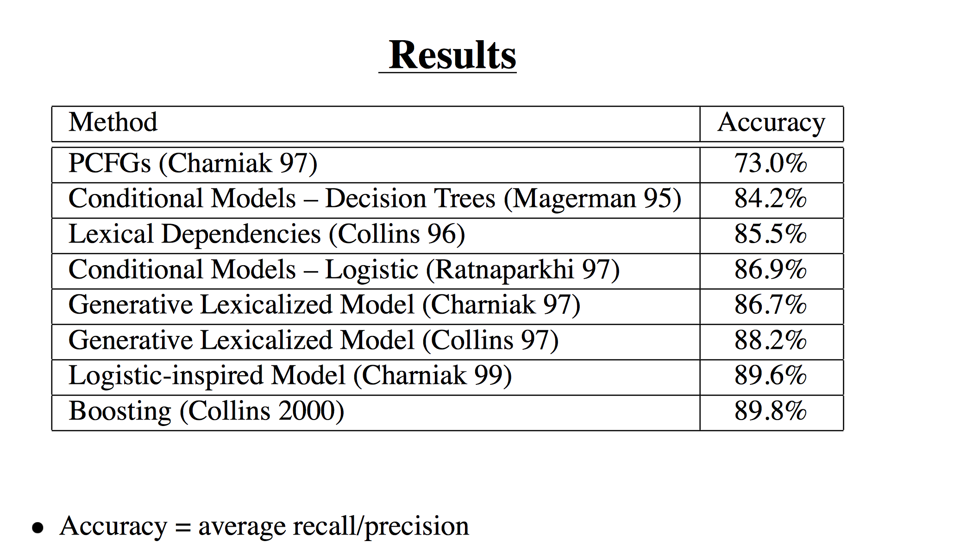

A rapid development in technology field will possibly one day help AI to fully understand human natural language. It will then serve more accurately in hospitals, helps in daily life activities, industrial field and many other sectors. It is predicted that AI will be used every sector in future that the human can be benefited.

**References:**

"A Beginner's Guide to Digital Signal Processing (DSP)." *A Beginner's Guide to Digital Signal Processing (DSP) | Design Center | Analog Devices*. N.p., n.d. Web. 16 Feb. 2017. <http://www.analog.com/en/design-center/landing-pages/001/beginners-guide-to-dsp.html>.

"Machine Learning vs. Natural Language Processing." *Lexalytics*. N.p., 27 July 2016. Web. 16 Feb. 2017. <https://www.lexalytics.com/lexablog/2012/machine-learning-vs-natural-language-processing-part-1>."Machine Learning Methods in Natural Language Processing." *Machine Learning Methods in Natural Language Processing*.

Columbia University, n.d. Web. <http://www.citationmachine.net/mla/cite-a-website/manual>.

"Amazon Alexa Gone Wild! (ORIGINAL)." *YouTube*. YouTube, 29 Dec. 2016. Web. 16 Feb. 2017. <https://www.youtube.com/watch?v=r5p0gqCIEa8>.